**LAB 03:**

**EXERCISE 01:**

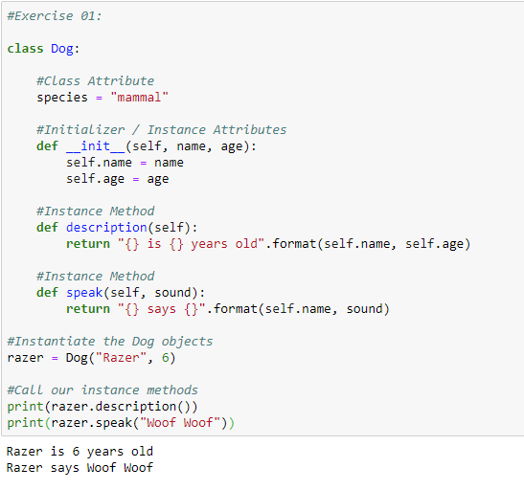

**EXERCISE 02:**

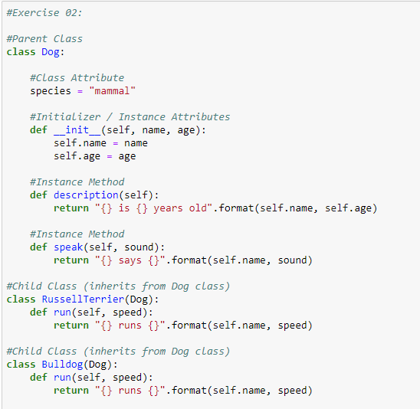

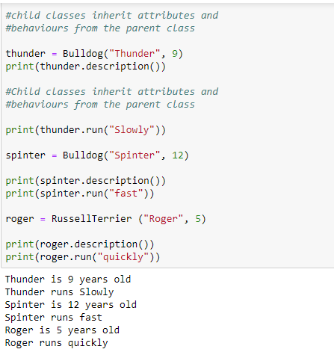

**EXERCISE 03:**

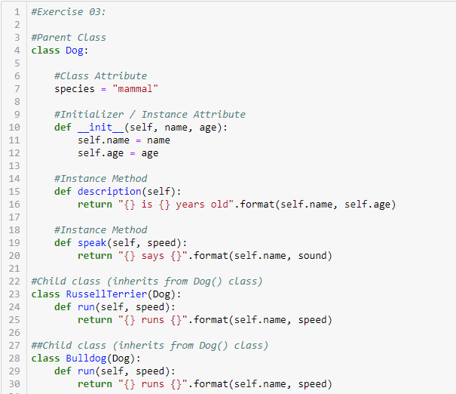

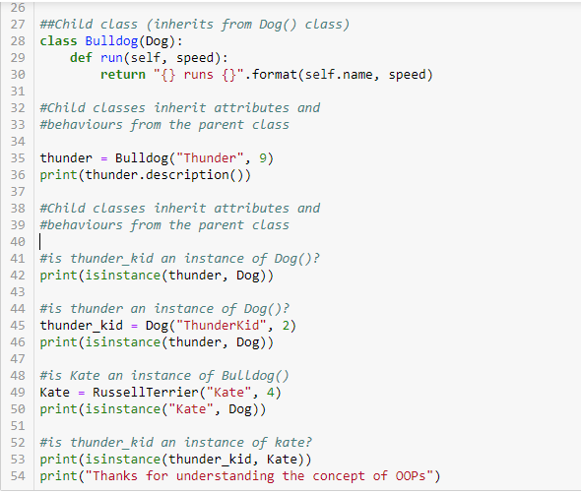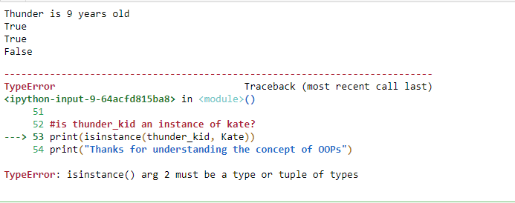

**PROGRAMMING EXERCISES:**

**OBJECT ORIENTED PROGRAMMING:**

**LAB 3:**

**TASK 3:**

**Create class and sub classes for different types of residential houses. Each house object has different parameters such as number of location of the house, rooms, parking available or not.**

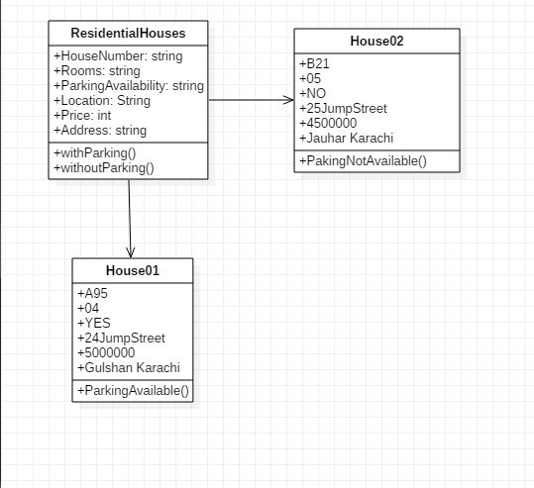

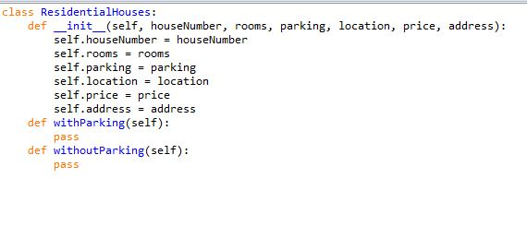

**TASK 4:**

**Create class and sub classes for differ types of vehicles for Toyota Motors. Each car object belongs to some particular model, color, and price, type of car such as saloon, luxury or sports.**

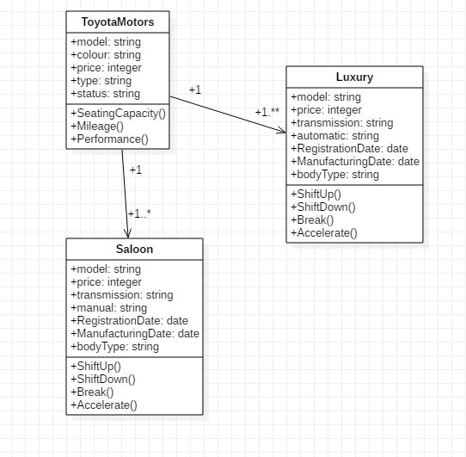

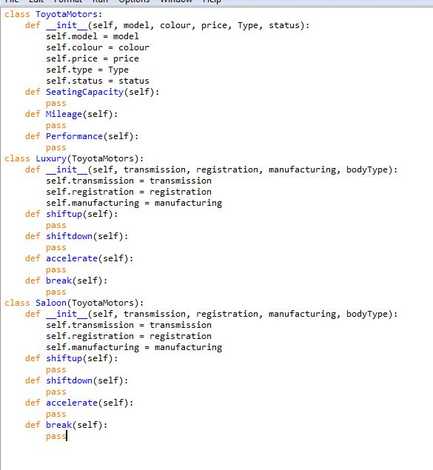

**TASK 5:**

**Create class and sub classes for different types of plants. Some of the plants have fruits that we can eat and some of them are poisonous. Some are local and some are imported from other countries.**

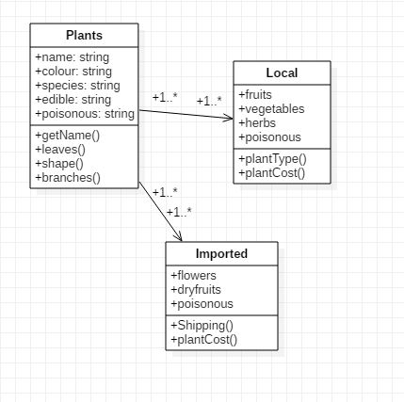

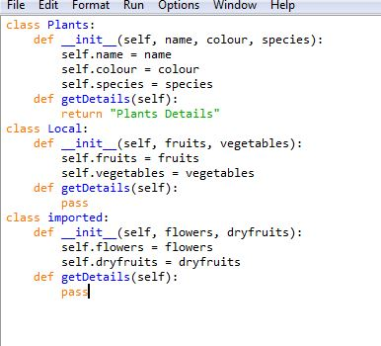

**TASK 6:**

You are hired in a mobile company which produces multiple mobiles each year. Select any mobile company create one main class, some sub classes, add some features and methods to operate the mobile and then create some objects for your friends and check how it will work.

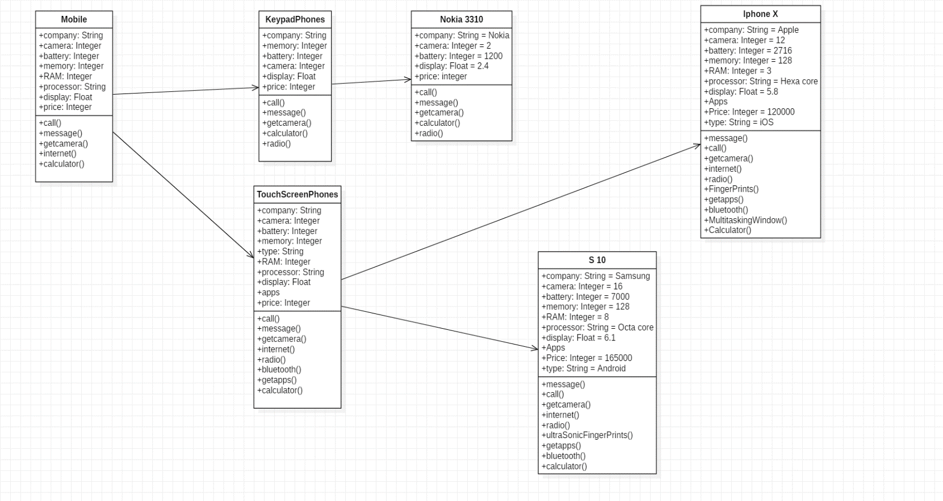

**TASK 7:**

You are doing programming for UIT admission office. Your task is to create some records for the students. You know that we have four types of students such as BS(CS) and BS(SE) is one type other is BE(Power/ Computer Systems /Telecommunications/Electrical), third type is master students and forth is short courses students. Now your task is to create some classes and subclasses to find how the system will work.

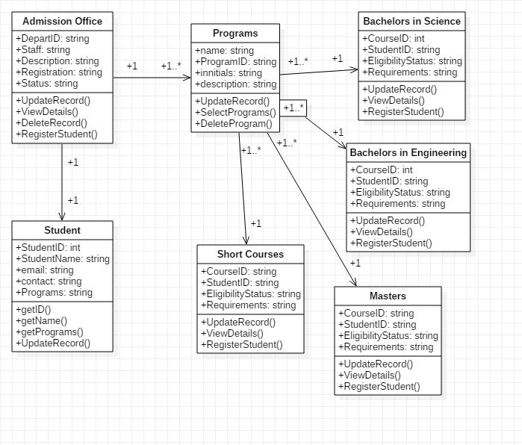

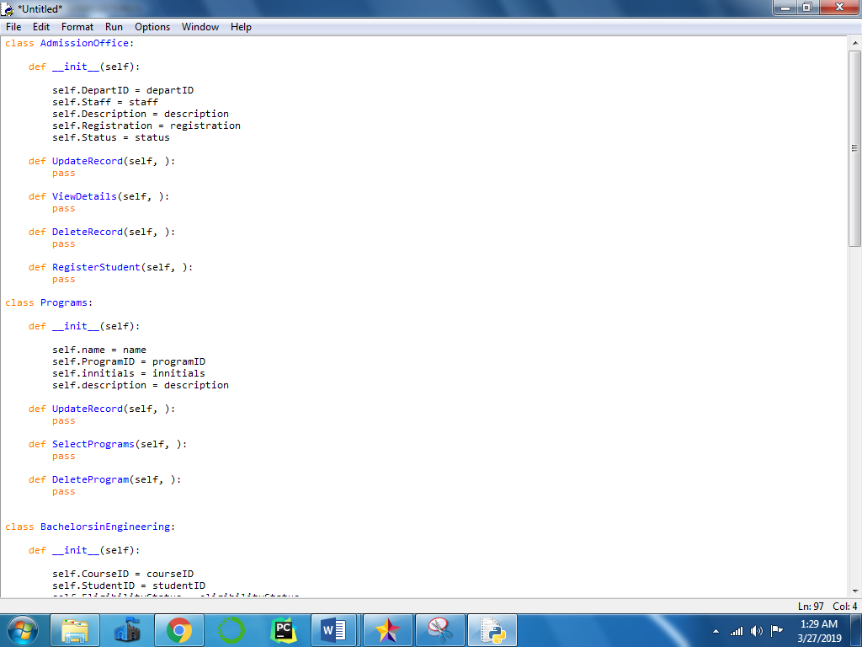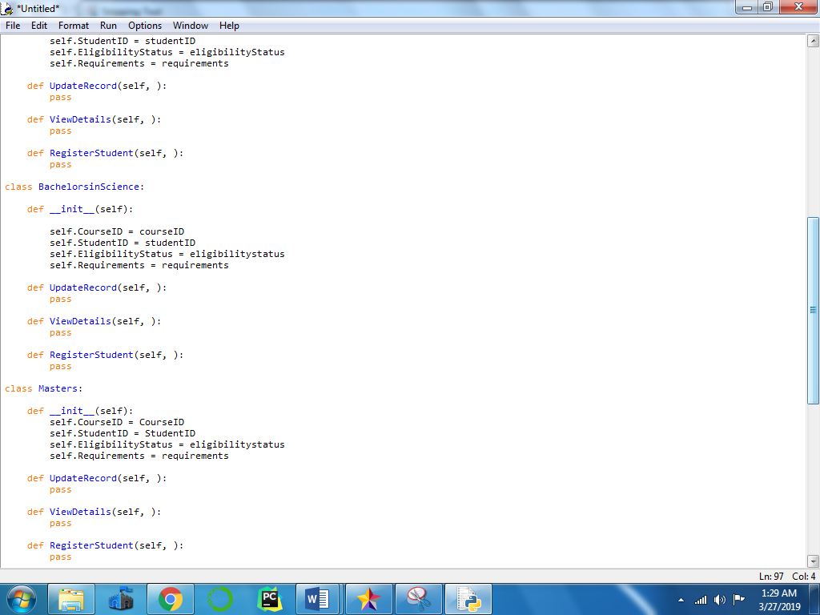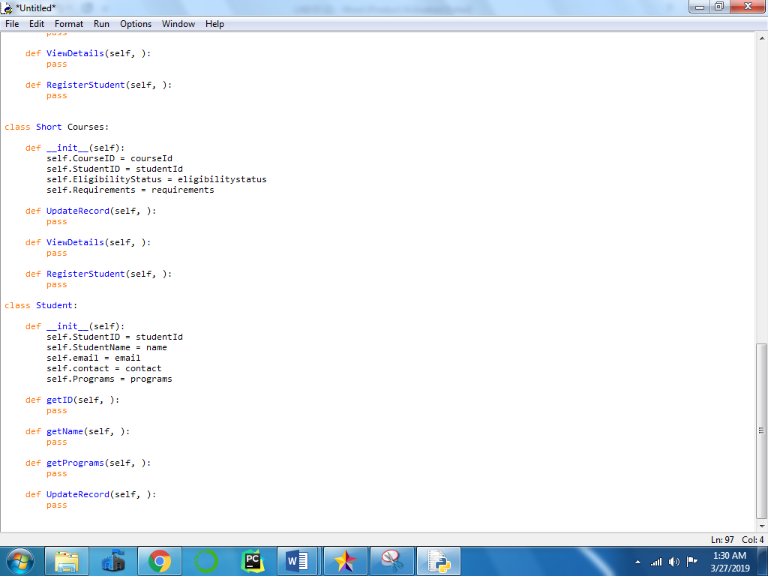

**TASK 8:**

**You are planning to create a project for Pizza Ordering System. Your primary task is to classify different types of pizza, its flavors, and sizes, crust type, price. How you analyze the system, according to your analysis perform the programming objectives.**

